Pneumatic Device Control

Connections & Control

(Graphical Interface and MATLAB Commands)

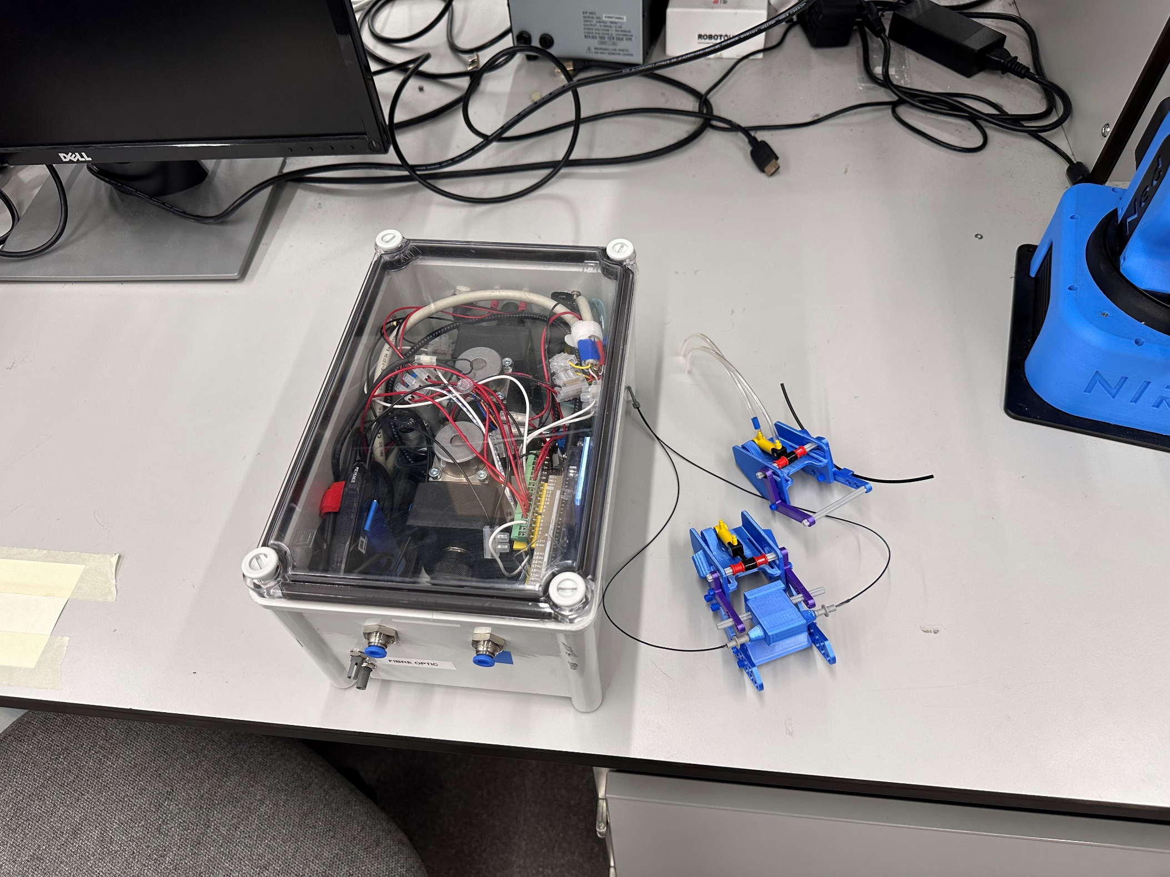

# Connection Guide

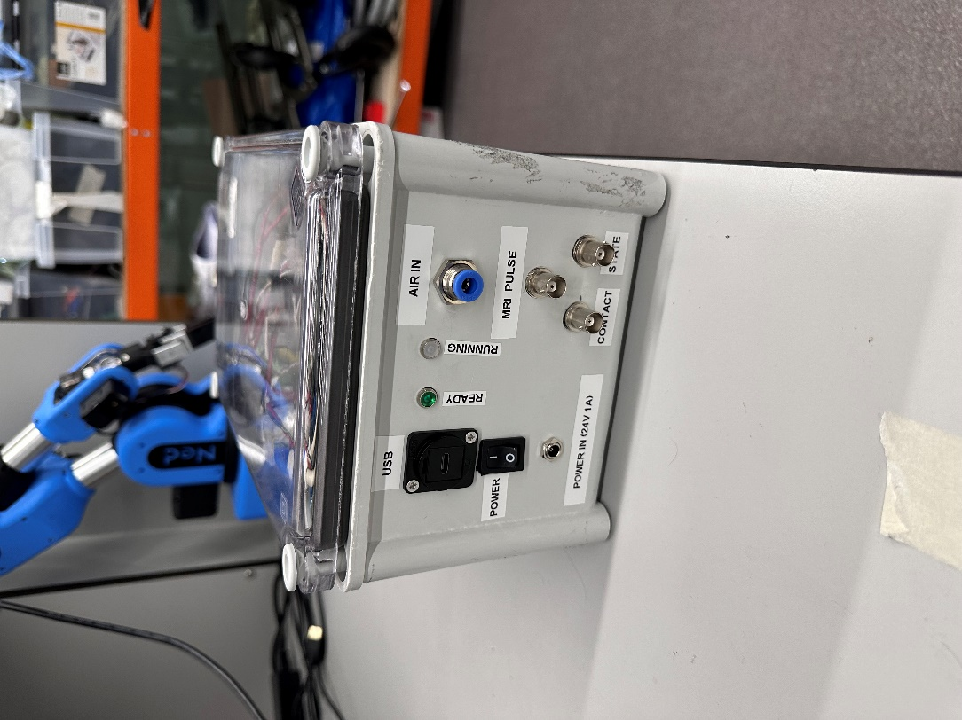 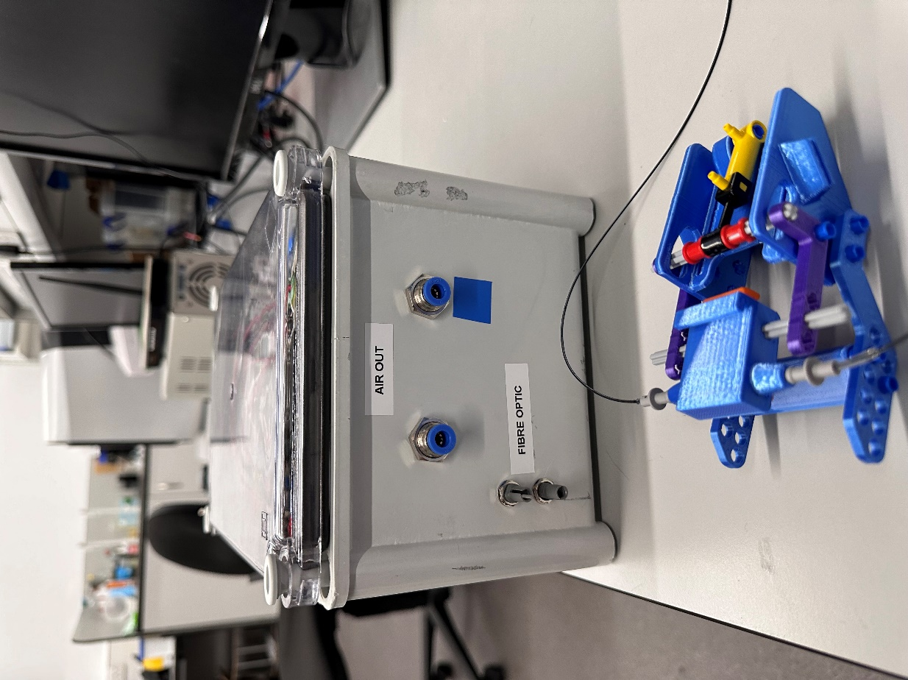

|  |  |
| --- | --- |
| USB | To computer |
| POWER | To switch device on/off |
| POWER IN (24V 1A) | To Power Supply (A black circle with a circle in the middle  Description automatically generated), with emergency stop connected |
| READY/POWER (Green LED) | On if device is powered |
| RUNNING  (White LED) | On if sequence is running |
| AIR IN | To air supply |
| MRI PULSE | To MRI scanner for synchronisation pulse |
| CONTACT | Only used in Hand Tapping Mode. HIGH when hand is tapped (when fibre light link is broken) and LOW when hand not tapped |
| STATE | HIGH during tap or flexion/tap and LOW for extension/release |
| AIR OUT | Output to hand device: Side with blue tape should go to back of hand device (away from the piston) and other side goes to side closer to the moving piston |
| FIBRE OPTIC | To the fibre optic lines, can connect either way |

The power supply should be connected to the device with the emergency stop button inline. It will cut the power to the device if pressed.

# Controls

## Graphical Interface

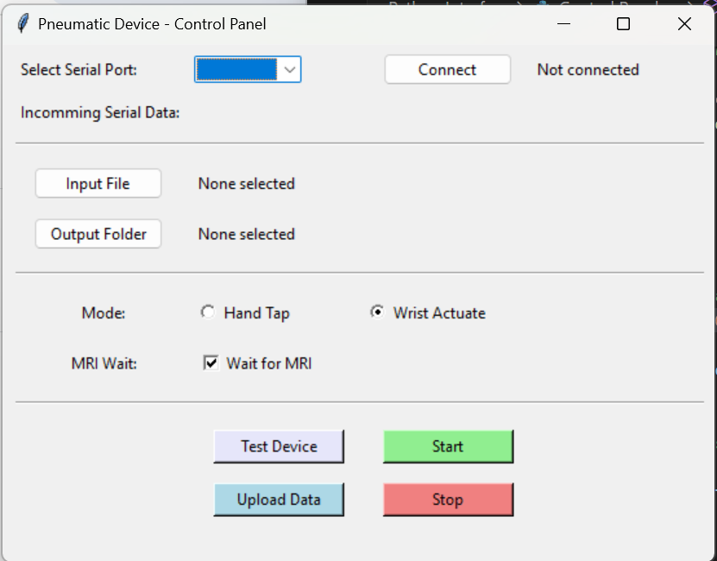

Run the executable file to open the interface. This may also open a terminal window which is used for diagnostics. You can minimise the console window but do not exit it.

1. Select the serial port connected to the device and click Connect. (You can check the COM port in device manager by checking what is there when the device is connected and disconnected).
2. Choose the input file.
3. Select a folder to save output data.
4. Choose the mode (Hand Tap or Wrist Actuate).
5. Set whether to wait for MRI signal (Checked for wait, Unchecked to run immediately).

**Button Functions**

* **Test Device**: Sends a test signal to the device to run a pattern, actuating one way for 2 seconds, then the other way for 2 seconds. You must select an output folder prior to running this.
* **Upload Data**: Uploads the selected input file to the device. The input file and mode need to be selected prior.
* **Start**: Starts the program. Set ‘MRI wait’ before starting. For Wrist Actuation, set MRI wait to True (MRI-triggered repetitions); for Hand Tapping, MRI wait can be checked or unchecked. (If checked it will start when the first MRI signal is received. If unchecked, it will run immediately).
* **Stop**: Stops the program.

(Note: If you mistakenly send the start command to wait for the MRI signal instead of starting immediately, you'll need to reset the device. You won't be able to re-upload data or resend the start command without resetting. To do this, turn off the power switch and disconnect the device from the USB simultaneously. Then, reconnect and switch the device back on. This process applies whether you’re using the Graphical Interface or MATLAB commands.

## MATLAB Commands

Download the folder from Google Drive. This folder contains example programs for three applications: Hand Tapping, Wrist Actuation, and Testing. Also inside, there is a subfolder called Control Functions. Add the Control Functions folder to the MATLAB path in the program you’re using. *(Important: If the Control Functions folder is located in a different directory from your MATLAB code, you’ll need to provide the full path.)*

The Control Functions include various commands. Examples of each function are in the provided example programs. The typical sequence to run the device involves first uploading data (either hand tapping or wrist actuation) then sending a start signal, which will trigger the device to run then then return data once the sequence finishes. You will establish a serial connection to the device prior to running these functions. (You can check the COM port in device manager by checking what appears when the device is connected and disconnected).

**UploadWristActuateData.m**

* Use this command to upload wrist actuation data.
* Required inputs:
  + The serial port of the pneumatic device.
  + Path to the wrist actuation sequence file (must be in the correct format – see example at the end of this document).

**UploadHandTapData.m**

* Use this command to upload hand tapping data.
* Required inputs:
  + The serial port of the pneumatic device.
  + Path to the hand tapping actuation sequence file (must be in the correct format).

**SendStartSignal.m**

* This command sends the start signal to begin data collection. Important: You must run either UploadWristActuateData.m or UploadHandTapData.m before this.
* Required inputs:
  + The device’s serial port.
  + A true or false value to specify start timing:

true – wait for an MRI signal before starting (required for wrist actuation).

false – start immediately (optional for hand tapping).

**SendTestSignal.m**

* Sends a test signal to the device to run a test pattern: the device actuates in one direction for 2 seconds, then in the opposite direction for 2 seconds.

**ReadData.m**

* Reads data from the hand device. It is automatically called by SendStartSignal.m. Data is returned via that function too.

(Note: If you mistakenly send the start command to wait for the MRI signal instead of starting immediately, you'll need to reset the device. You won't be able to re-upload data or resend the start command without resetting. To do this, turn off the power switch and disconnect the device from the USB simultaneously. Then, reconnect and switch the device back on. This process applies whether you’re using the Graphical Interface or MATLAB commands.

# Input File formats

## Hand Tapping

This file must be a comma separated file with 3 values per row.

1. **Time of Hand Tap Initiation**: This is the timestamp when the hand tap begins.
2. **Tap Intensity**: The intensity of the tap, given as a percentage.
3. **Tap Duration**: The duration of the tap.
   * A positive value here specifies the duration between the initiation and end of the tapping movement in milliseconds. For example, a value of 300 means there will be a 300ms gap between the initiation signal and the end signal. (In reality there will be a delay as the device need to move to tap the hand. This delay will vary depending on the distance between the hand tapper in its retracted position and the skin of the participant.
   * A negative value enables automatic timing, using fibre optic data to determine the duration. For instance, -300 would start timing from the moment of contact and send a signal to stop the tap after.

E.g.

## Wrist Actuation

Files must be a comma separated file (csv) with a single 0 or 1 on each line.

E.g.

